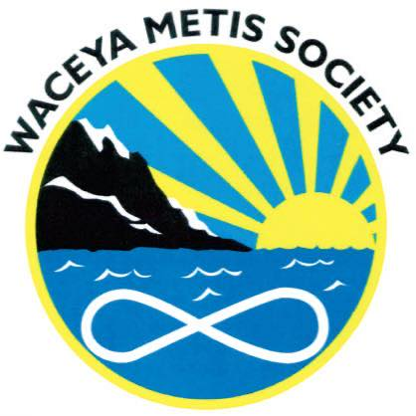
AGENDA
Wednesday, February 8, 2023, 6:30 PM
Waceya Office, 5631 176A St., Surrey, BC

- Opening Prayer
- Introductions
- Old Business
- New Business
  - Alysha would like to discuss new Mission Statement
  - Review funding possibilities
  - Decide whether we should open during Batoche week
  - Go over any questions for Regional Meeting to be attended by Kelly on Thursday, February 9, 2023.

