Waceya Metis Society
Christmas Dinner & Dance
Murrayville Community Memorial Hall
21667 48th Avenue
Langley, BC
Frida, December 8th
Doors open at 5:30 PM
RSVP Required No LaterThan Thursdsy, November 30th

Ticket Sales
Door Prizes
50/50
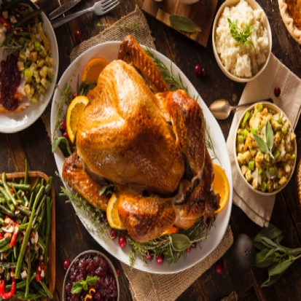

Dinner: turkey
Ham
Potatoes
Veggies
Salads
Dessert
Coffee AND/OR TEA
ENTERTAINMENT
By
KEITH HILL, FIDDLE
&
FERGUS FURLONG, GUITAR
Plus
METIS YOUTH JIGGERS
&
SPECIAL GUEST, METIS SANTA

